
19

Submitted by: Name:Abdullah
Registration No: 2025-CE-47(A)

Submitted to:

Sir Mehmood

TOPIC:

Experiment 2:
Measurements of Waveforms and Fundamental Quantities, Basic resistive circuit.

[Circuit Analysis (Lab #2)]

20

Resistor | Input voltage | RMS Voltage | P-P Voltage
R1 | 5V | 1.07V | 3.04V
R2 | 5V | 0.69V | 1.96V

0 t/4 t/2 3t/4 T Time
0 t/4 t/2 3t/4 T Time

2.5
1.5
0.
0

-1.5

-2.5

V
1.52
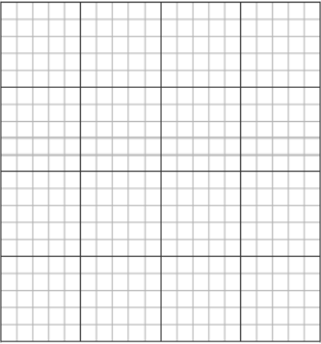

0.5
0
-0.5

-1.52

V
Figure 2 Input Voltage Signal Figure 3 Voltage Signal across R1


0 t/4 t/2 3t/4 T Time 0 t/4 t/2 3t/4 T Time
0.98 |  | 3.5
0.45 |  | 1.5
0 |  | 0
-0.45 |  | -1.5
-0.98 |  | -3.5
V |  | V
 | Figure 5 Voltage Signal across R2



Figure 6 Draw 7V Sinusoidal

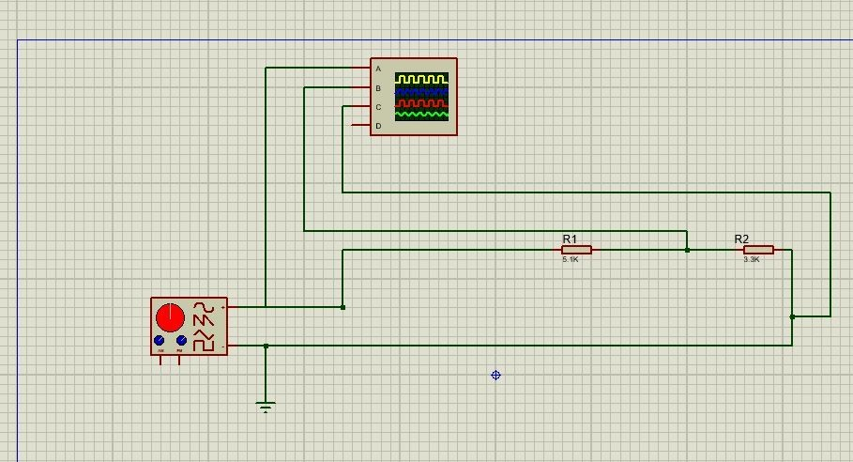

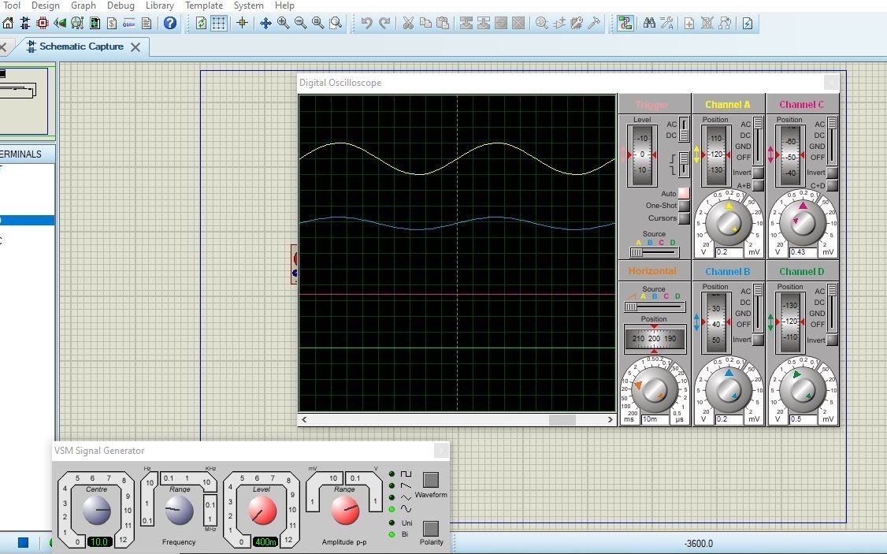

21

Experiment # 2
SIGNAL GENERATOR AND OSCILLOSCOPE
- Use the signal generator and the oscilloscope to perform the following tasks.
- Build circuit ‘B’ shown below in Figure 7.
- Set the signal generator to generate a sinusoidal signal with a frequency of 200 Hz and peak-to peak voltage of 7V.
- Set up one probe across input signal, and another across R1, R2 and R3 alternatively.
- Measure and draw all the voltages and time related parameters on the graphs below.
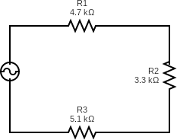

Resistor | Input voltage | RMS Voltage | P-P Voltage
R1 | 7V | 0.89V | 2.51V
R2 | 7V | 0.62V | 1.76V
R3 | 7V | 0.97V | 2.73V
R1 and R2 | 7V | 1.51V | 4.27V
R2 and R3 | 7V | 1.59V | 4.49V



0 t/4 t/2 3t/4 T Time 0 t/4 t/2 3t/4 T Time

3.5

1.5
0
-1.5

-3.5

V
1.255

0.628

0
-0.628

-1.255

V

Figure 8 Input Voltage Signal Figure 9 Voltage Signal across R1

22

0 t/4 t/2 3t/4 T Time 0 t/4 t/2 3t/4 T Time


1.76

0.88

0
-0.88

-1.76

V
2.73


1.36
0
-1.36

-2.73

V

Figure 10 Voltage Signal across R2 Figure 11 Voltage Signal across R3

0 t/4 t/2 3t/4 T Time 0 t/4 t/2 3t/4 T


Time

2.135

1.07
0

-1.07

-2.135

V
2.245


1.122
0
-1.122

-2.245

V

Figure 12 Voltage Signal across R1 and R2 Figure 13 Voltage Signal across R2 and R3

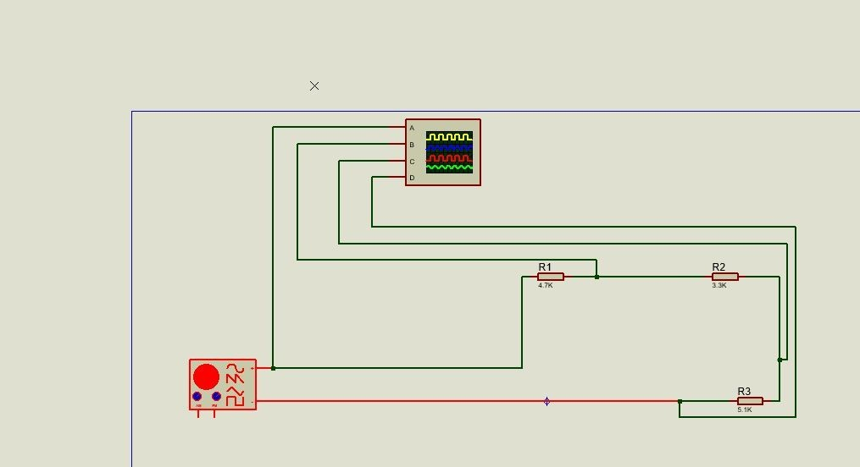

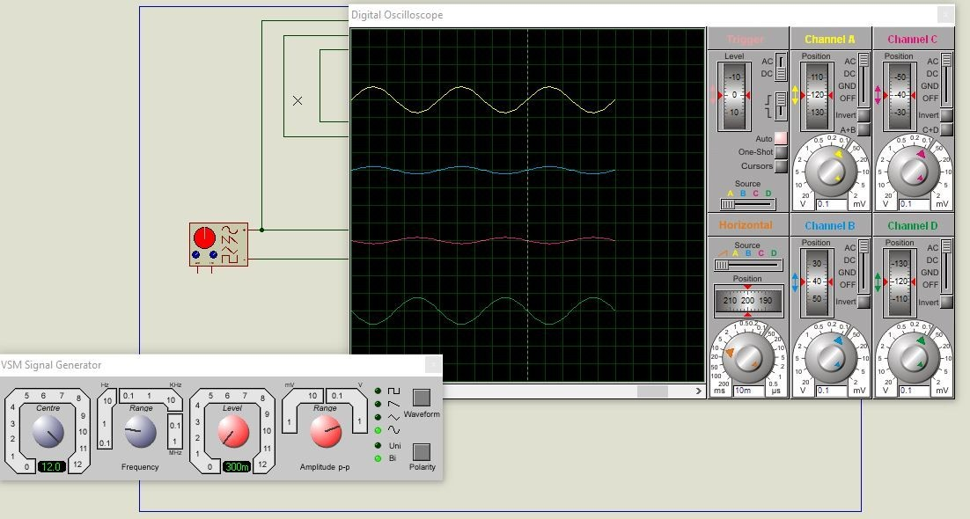

- Define Ohm’s law.
23
Post Lab Questions

T_h_e current flowin_g t_hrou_gh_a con_d_uc_tor is _d_irectly p_r_o_por_tiona_l to t_he
_v_o_ltage acro_s s it,_and i_n_v_er_s_e_ly pr_o por_ti_onal to its re_s_i_s_tan_ce , _p_r_ovided the
_t_emp_erature_remains constant.
V = I R
- What is resistor?
An _e lectron_ic devi_ce that r_esists or _o_p_pos_e_s th_e flo_w of electric cu_rrent in a circuit.
R = V/I

- How resistor works?
_When c_urrent flo_ws th_r_o_ug_h a resisto_r ,_the r_esistor _creates friction_against
_T_he _electron_s , slow_ing them do_wn and re_d_u_cing th_e_curr_e nt .

- What is your inference from the input and output waveforms on oscilloscope?
_T_he _inp_ut an_d the outp_u_t w_aveforms_have t_h_e s_ame_f_r_e_quency_and
s_ha_pe_,but the output v_olt_age acros_s e_ach r_esistor _is smaller t_h_an the input _
volt_age_. This is be_cau_se v_o_lt_age i_s_div_ided among t_h_e resis_tors_acc_ord_i_n_g to th_eir_res_istanc_e
_values.
- Show calculations of 7V input signal (Figure 10) from signal generator.
  - Voltage calculations (Following volt/dev and number of boxes of oscilloscope)
  - Frequency/Period calculations (Following Steps in frequency measurements section)
  - Current calculation (Ohm Law)
(a) V_{p-p} = 7V
V_{r}_ms = 7/2_squrt._2
V_{r_m s} = 2_.47_V
(b) f =_20_0H_z
(c) I = V_{rms} / R_{T}
I = 0_.189_mA

